# \Get to know your classmates

One of the best ways to find success in this program is to get to know other learners. Connecting with other people makes it easier to share questions and concerns, or brainstorm solutions for any challenges you might face together. Plus, if you don’t understand something when looking back over your notes, you can always reach out by posting a new thread with your question. By working together, you combine your understanding and deepen your knowledge.

**Update your profile**

To connect with other learners, it helps to [update your profile](https://www.coursera.org/account-profile). You can do this by clicking on your name at the top-right corner of this screen, then click the Profile link in the menu. You will be able to add information about your past work experience and education, your career goals, and any details about yourself that you would like to share. This way, when people find you in the discussion forums, they can check out your profile and get to know you better. Only share information that you are comfortable sharing—you can change the privacy option in your settings if you would like to make your profile more private.

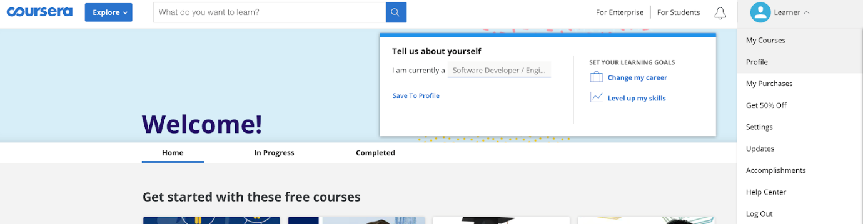

**Meet and greet**

It also helps to use the [Meet and Greet discussion prompt](https://www.coursera.org/learn/foundations-data/discussionPrompt/5a0P9/meet-and-greet) to introduce yourself, share a brief introduction, and offer help when you’re able. Likewise, be sure to read some of the other learners’ posts. You might be surprised by their interesting life journeys or the things you have in common. Leave a comment, a quick hello, or words of encouragement on their posts as you start this adventure together.

Chances are, in addition to taking this course, you are balancing work and personal responsibilities. With all that is going on, it can be easy to isolate yourself from other learners. But when you connect with others and make friends, learning is a lot more fun. Let’s explore the exciting future of data analytics together!